
VILNIAUS UNIVERSITY
FACULTY OF MATHEMATICS AND INFORMATICS
SOFTWARE ENGINEERING STUDY PROGRAM

Software Systems Design

Titas Stongvila, Laimis Papinigis, Rokas Danielius Didrikas, Daniel Sosna
Supervisor: Vasilij Savin
Table of Contents
MiniSheets Technical Specification 3
1. Overview 3
1.1 High concept 3
1.2 Core audience 3
1.3 Business problem 3
2. Feature list (MoSCoW) 3
3. Functional specification 4
3.1 Window and sheets (F-09) 5
3.2 Grid and navigation 5
3.3 Cell input (F-01) 5
3.4 Value formats and styling 6
3.5 Formulas (F-02) 7
3.6 Function catalogue (F-02) 9
3.7 Copy, cut and paste (F-05) 10
3.8 Undo and redo (F-06) 10
3.9 Workbook files (F-07) 11
3.10 CSV import and export (F-08) 11
3.11 Recovery copy, auto-save and error log 12
3.12 Locale (F-10) 12
3.13 Could features 13
4. Business flows 13
4.1 Commit a cell edit 13
4.2 Save a workbook 14
4.3 Import a CSV file 14
4.4 Start-up and recovery 15
5. Non-functional requirements 15
5.1 Limits 15
5.2 Requirements 15
6. High-level architecture 16
6.1 Package diagram 16
6.2 Class diagram 17
6.3 Implementation recommendations 18
7. UI/UX wireframes 18
7.1 Screens 18
7.2 Message catalogue 21
7.3 Keyboard shortcuts 22
7.4 Screen transitions 22
8. Data model 22
8.1 Class diagram 23
8.2 Entities 23
8.3 .msheet file format (version 1) 24
8.4 Settings file 25

MiniSheets Technical Specification

1. Overview

1.1 High concept
MiniSheets is an offline desktop spreadsheet. It gives everyday users what they actually need: a grid of cells, formulas, formatting, multiple sheets and CSV interchange. It needs no account, subscription or internet connection.
The user types text, numbers, currency amounts, dates or formulas into cells, and every cell that depends on a changed value recalculates automatically. The user can format and colour cells, add sheets, and undo or redo changes. A workbook is saved as a single .msheet file, and data is exchanged with other tools through CSV import and export.

1.2 Core audience
Segment | Typical use | What they need most
Students and teachers | Lab measurements, grade tracking, simple statistics | Formulas, CSV import from instruments
Small-business owners and freelancers | Invoices, price lists, monthly expenses | Currency format, exact decimal arithmetic, save and load
Home users | Household budgets, lists | Fast start-up, simple UI, works offline

1.3 Business problem
People who need a spreadsheet for small, everyday tasks are poorly served by the current options:
Alternative | Why it does not fit
Paper, text editor | Cannot calculate. Totals must be recomputed by hand after every change, which causes errors
Microsoft Excel 365 | Paid licence or Microsoft 365 subscription (the free web version needs a Microsoft account and internet), and hundreds of features this audience never uses
Google Sheets and other web tools | Built for the browser and a Google account. Offline use needs extra setup in Chrome, and data is stored on third-party servers
LibreOffice Calc | Free and offline, but a large office-suite installation with a dense, complex interface
MiniSheets is a small, local-only tool that differs from these options in four ways:
- It contains only the features in section 2, so there is nothing to learn before the first sum.
- It starts in under 2 seconds, without a sign-in or a start screen, straight into an empty workbook.
- Currency amounts are calculated exactly (0.1 + 0.2 = 0.3), so invoice and budget totals have no rounding errors.
- It needs no account, subscription or network connection, and files never leave the user’s computer.

2. Feature list (MoSCoW)
Must and Should features are required for acceptance. Could features are optional, but the data model and file format already contain their fields.
ID | Feature | Priority | Scope | Section
F-01 | Cell input | Must | Type, edit, commit, cancel and clear the content of the active cell | 3.3
F-02 | Formulas | Must | Operators, references to cells and ranges on the same sheet, 17 functions, automatic recalculation | 3.5, 3.6
F-03 | Value formats | Must | General, Text, Number, Currency, Date | 3.4
F-04 | Cell colours | Must | Fill and text colour from a 16-colour palette | 3.4.5
F-05 | Copy, cut and paste | Must | Content and style of the active cell | 3.7
F-06 | Undo and redo | Must | Every workbook change, 100 steps | 3.8
F-07 | Workbook files | Must | New, Open, Save, Save as, unsaved-changes check | 3.9
F-08 | CSV import and export | Must | Import into a new sheet with a preview, export the active sheet | 3.10
F-09 | Multiple sheets | Must | Add, rename, delete and switch sheets | 3.1
F-10 | Locale | Must | en-US and lt-LT number, date and formula style | 3.12
F-11 | Recovery copy | Must | Hidden copy every 120 s, offered after a crash | 3.11.1
F-12 | Menus, toolbar and shortcuts | Must | Main window controls and the shortcut table | 7.1
F-13 | Error log | Must | Local log file of errors and key events, for tracing problems | 3.11.3
F-14 | Column width and row height | Should | Drag a header border to resize | 3.2.3
F-15 | Auto-save | Should | Saves the open file at a chosen interval, off by default | 3.11.2
F-16 | Find | Could | Find text on the active sheet | 3.13.1
F-17 | Borders | Could | All four borders of a cell on or off | 3.13.2
F-18 | Insert and delete rows and columns | Could | With formula reference rewriting | 3.13.3
Won’t have in this release:
Area | Not included
Selection and editing | Range selection (more than one cell, whole rows or whole columns), select-all, fill handle, context menus
Formulas | References to other sheets (Sheet2!A1), whole-column references (A:A), time-of-day values
Formatting | Text style (bold, italic, alignment), merged cells, text overflow modes (wrap, truncate), auto-fit of columns and rows, conditional formatting
Data tools | Charts, filtering and sorting, macros
Files | .xlsx files, printing, a recent-files list, file associations
Window | More than one window, freeze panes, zoom, hidden rows and columns, sheet reordering, a Help menu, translated UI text
Platforms and services | Collaboration, cloud sync, builds for macOS, Linux, mobile and the web

3. Functional specification
This section describes what the user does and what the app does in response. Component names such as ValueParser or Recalculator refer to the blueprint in section 6. Suggested algorithms and libraries are collected in 6.3. They are not requirements, and any approach that gives the same behaviour is acceptable.
Every change to a workbook is one undo step (3.8). Limits are listed once, in 5.1. Messages (M-nn) are listed in 7.2 and shortcuts in 7.3.
The following terms are used throughout the document.
Term | Meaning
Workbook | One document, saved as one .msheet file. Holds 1 to 32 sheets
Sheet | One grid of rows 1 to 10 000 and columns A to ZZ, with its own name, column widths and row heights
Cell address | Column letters and row number, e.g. B7. The absolute form $B$7 exists only inside formulas
Active cell | The one selected cell. It receives typed input and every formatting, clipboard and clear action
Raw input | What is stored for a cell: the user’s input in canonical form
Canonical form | Locale-independent spelling: . as decimal point, no thousands separator, ISO dates (yyyy-MM-dd), , between function arguments, upper-case function names. Text is stored exactly as typed
Edit text | Raw input written in the current locale’s style, as shown in the cell editor and the formula bar
Value | The result computed from raw input (8.2.5)
Display text | The value formatted for the grid (3.4.3)
Dirty | The workbook has unsaved changes, shown as * in the title bar

3.1 Window and sheets (F-09)
- One window holds one workbook. Starting MiniSheets while it is running brings the running window to the front, and the new process exits.
- Title bar: MiniSheets - <file name> with the extension, or MiniSheets - Untitled for a never-saved workbook. While the workbook is dirty, * is appended.
- At start-up the recovery check runs first (3.11.1), then a new workbook opens at the window size stored in settings (8.4).
- A new workbook has one empty sheet named Sheet1, no file path, a new workbook id and an empty undo history, and is not dirty.
Operation | Trigger | Result
Add | + tab button, Sheet > Add sheet, Ctrl+Shift+N | With 32 sheets: M-08. Otherwise a sheet named SheetN is added after the last tab and becomes active. N is the smallest positive integer not used by another SheetN
Rename | Double-click a tab, Sheet > Rename sheet | The tab becomes a text box with the name selected. Enter or a click elsewhere commits, Esc cancels. An invalid name is not committed: the box gets a red border and tooltip M-14 and stays open
Delete | Sheet > Delete sheet (disabled with one sheet) | W5 asks with M-02. On Delete, the sheet is removed and the tab to its right becomes active (the tab to its left if it was the last)
Switch | Click a tab, or Ctrl+Page Down and Ctrl+Page Up | The clicked, next or previous tab becomes active, without wrap-around. Not undoable
A sheet name has 1 to 31 characters after leading and trailing spaces are removed, contains none of ! : / \ ? * [ ], and differs from every other sheet name, ignoring letter case. Tabs are shown in workbook order. When they do not fit, the tab strip scrolls with the mouse wheel and keeps the active tab visible.

3.2 Grid and navigation

3.2.1 Active cell
Clicking a cell makes it the active cell. A1 is active in a new workbook, after Open and after switching to a sheet for the first time. Each sheet remembers its active cell while the workbook is open. The name box shows the active cell’s address and cannot be edited.

3.2.2 Keys in Ready mode
Key | Result
Arrow | Moves the active cell by one cell. At the edge of the sheet nothing happens
Home | Column A of the current row
Ctrl+Home | A1
Page Up, Page Down | Moves the active cell and the view by the number of fully visible rows, stopping at row 1 or 10 000
Mouse wheel | Scrolls the view by 3 rows without moving the active cell
After every keyboard move the view scrolls so that the active cell is visible.

3.2.3 Column width and row height (Should, F-14)
Dragging the border at the right of a column header or at the bottom of a row header resizes that column or row. The size follows the pointer within the limits of 5.1. Releasing the mouse button is one undo step. Releasing at the original size changes nothing. Without F-14 every column and row has the default size.

3.3 Cell input (F-01)

3.3.1 Edit modes
Mode | Started by | Arrow keys | Commit | Cancel
Ready | Default | Move the active cell (3.2.2)
Enter | Typing a printable character in Ready mode. The editor opens over the cell and contains that character | Commit, then move | Enter, Tab, Shift+Enter, Shift+Tab, an arrow key, clicking another cell | Esc
Edit | F2, double-clicking the cell, clicking the formula bar. The editor contains the edit text with the caret at the end | Left, Right, Home and End move the caret. Up and Down do nothing | Enter, Tab, Shift+Enter, Shift+Tab, clicking another cell | Esc
- After a commit, Enter moves the active cell down, Shift+Enter up, Tab right and Shift+Tab left. At the edge of the sheet it stays where it is. Clicking another cell commits and then makes the clicked cell active.
- Esc restores the cell and nothing is stored. Committing text equal to the current edit text changes nothing and adds no undo step.
- The editor and the formula bar always show the same text. In Enter and Edit mode, Ctrl+C, Ctrl+X, Ctrl+V, Ctrl+Z and Ctrl+Y act on the editor text, not on cells.
- Cell text is a single line of at most 32 767 characters. Further characters are discarded, and each line break in pasted text becomes one space.

3.3.2 Commit and clear
- A commit is one undo step. The input is classified by the cell’s value format (3.4), and a formula is parsed (3.5). The cell and all cells that depend on it are recalculated (3.5.6) and redrawn.
- Committing an empty text, pressing Delete or Backspace in Ready mode, or choosing Edit > Clear contents empties the active cell and keeps its style. This is one undo step, and nothing happens if the cell is already empty.

3.4 Value formats and styling

3.4.1 Value formats (F-03)
Every cell has one format, and new cells are General. The format decides how typed input is classified and how the value is displayed.
Format | Value stored | Handlers tried (3.4.2) | Not recognised | Options
General | Boolean, number, decimal, date or text | Boolean, Number, Currency, Date, in this order. A currency amount switches the cell to Currency with that currency and 2 decimals | Text | None
Text | Text | None: input is kept as typed (also =1+1) |  | None
Number | Number (IEEE-754 double) | Number | Text with a warning triangle | 0 to 10 decimals, default 2
Currency | Decimal (exact, 3.5.4) | Currency. Without a symbol the cell’s currency is used, and a different symbol or code switches the cell to that currency | Text with a warning triangle | 0 to 4 decimals, default 2. Currency EUR, USD, GBP or the locale’s default
Date | Date | Date | Text with a warning triangle | None

3.4.2 Input classification
ValueParser classifies every committed input. Input starting with ' is text (the apostrophe is kept in the raw input but not shown in the grid). Input starting with = is a formula (3.5), except in a Text cell, and its value is displayed in the cell’s format. Any other input goes to the type handlers allowed by the cell’s format. Each handler gets the text and the current locale (3.12). The first handler that recognises the input returns the value and its canonical form.
Handler | Recognises | Examples
BooleanHandler | TRUE or FALSE in any case | true gives TRUE
NumberHandler | A number in the locale’s spelling: optional sign, digits optionally grouped with the thousands separator, optional decimal part, optional exponent. The canonical spelling is accepted in every locale | 1,234.5 (en-US), 1 234,5 (lt-LT) and 1234.5 give 1234.5. 1.5E3 gives 1500. 50% is not a number
CurrencyHandler | A number with €, $, £, EUR, USD or GBP before or after it, with or without a space | €12 and 12 EUR give 12 EUR. -€12, €-12 and -12 € give -12 EUR
DateHandler | A full date in the locale’s short-date pattern or ISO yyyy-MM-dd, with 1 or 2 digits for day and month and 4 for the year | 10/18/2026 (en-US) and 2026-10-18 give 2026-10-18. 13/10 is not a date
- Recognised input is stored in canonical form (1 234,5 becomes 1234.5), so a file opens the same in every locale.
- Changing a cell’s format classifies its stored raw input again with the new format. The raw input itself does not change.
- A value that does not fit its cell’s format (e.g. text in a Number cell) shows a warning triangle in the cell’s top-left corner. Hovering over the triangle shows M-15.

3.4.3 Display
ValueFormatter turns a value, the cell’s style and the locale into display text, using the rules below.
Value | General | Number | Currency | Date
Number or decimal | General number rule | Number rule | Currency rule | General number rule
Date | Locale short date | Locale short date | Locale short date | Locale short date

Rule | Output
General number rule | Up to 10 decimals with trailing zeros removed, the locale’s decimal separator and no thousands separator. If |x| ≥ 10^15 or 0 < |x| < 10^-10, scientific notation is used (1.23E+15, 5E-11)
Number rule | The locale’s decimal and thousands separators and the cell’s decimals, rounded half away from zero
Currency rule | As the Number rule, with the currency symbol placed as the locale places it: $1,234.50 and -$12.00 (en-US), 1 234,50 € and -12,00 € (lt-LT)
- Text, booleans and errors look the same in every format. Numbers, decimals and dates are right-aligned, text and errors left-aligned, booleans centred.
- A number, decimal or date wider than its column displays ###. Text is clipped at the cell's right border.
- Cells use Segoe UI 13 px with 4 px padding left and right, black text on a white background. Errors are red (#FF0000). Hovering an error shows its meaning (3.5.5).
- Gridlines are 1 px #D9D9D9. The active cell has a 2 px #0070C0 border, and a pending cut a 1 px dashed black border.

3.4.4 Applying a format
The toolbar format drop-down shows the active cell’s format. The drop-down and Format > Number format set the active cell’s format with that format’s default options. Toolbar .00+ and .00- (Format > Increase or Decrease decimals) change the decimals of a Number or Currency cell by one within its range. The Currency submenu of Format > Number format offers Locale default, EUR, USD and GBP. Number cells always use the thousands separator. Each change is one undo step.

3.4.5 Colours (F-04)
Toolbar Fill and Text (Format > Fill colour, Text colour) open the palette with 16 swatches and a No colour button. A swatch sets the active cell’s fill or text colour, and No colour restores the white fill or black text.
Row | 1 | 2 | 3 | 4 | 5 | 6 | 7 | 8
1 | #000000 | #7F7F7F | #D9D9D9 | #FFFFFF | #C00000 | #FF0000 | #FFC000 | #FFFF00
2 | #92D050 | #00B050 | #00B0F0 | #0070C0 | #002060 | #7030A0 | #F4B183 | #BDD7EE

3.5 Formulas (F-02)

3.5.1 Syntax
A formula is = followed by an expression built from the elements below. The user types and sees formulas in the locale’s style: the locale’s decimal separator in numbers and its argument separator between arguments (3.12). They are stored in canonical form. Text inside quotes is never converted.
Element | Examples | Rules
Number | 12, 1.5, 2E-3 | Digits, optional decimal part, optional exponent
Text | "Total", "say ""hi""" | In double quotes. "" stands for one quote character
Boolean, error | TRUE, #DIV/0! | Any error code of 3.5.5
Cell reference | B7, $B$7, B$7 | A cell of the formula’s own sheet. $ keeps the column or row fixed when the formula is copied (3.5.7)
Range | A1:C5 | Only as a function argument. Elsewhere (=A1:A3) it gives #VALUE!. Stored top-left first (C5:A1 becomes A1:C5)
Function call | SUM(A1:A3, 5) | A function of 3.6 with its arguments
Operators, parentheses | (1+2)*3, -A1, 50% | Operators of 3.5.2
- Function names, booleans, column letters, E and error codes are case-insensitive and stored upper-case. Spaces between elements are kept as typed.
- A name that is not a function gives #NAME?. An address outside A1:ZZ10000 gives #REF!.
- A formula that cannot be parsed, is longer than 8 192 characters or nests deeper than 64 levels is stored as typed and gives #ERROR!.

3.5.2 Operators
Precedence (high to low) | Operators | Notes
1 | postfix % | Divides by 100: 50% = 0.5
2 | unary - + | -2^2 = 4
3 | ^ | Left-associative: 2^3^2 = 64
4 | * / | Division by 0 gives #DIV/0!
5 | + -
6 | & | Joins text
7 | = <> < > <= >= | TRUE or FALSE

3.5.3 Type rules
Case | Rule
Errors | An operator or function with an error operand returns that error, the leftmost if there are several. Exceptions are IFERROR and the branch of IF that is not taken
Empty cells, booleans | An empty cell is 0 in arithmetic and "" in text. TRUE and FALSE are 1 and 0 in arithmetic
Text in arithmetic | Classified like input typed into a General cell (3.4.2): "12,5" is 12.5 under lt-LT, and a date text becomes a date (3.5.4). Any other text gives #VALUE!
Comparisons | Numbers and decimals compare by value. Dates compare only with dates, an earlier date being smaller. Text compares only with text, ignoring case, and booleans only with booleans (FALSE < TRUE). Any other pair gives #VALUE!. An empty cell takes the other operand's type (0, "" or FALSE), except that an empty cell compared with a date gives #VALUE!. Two empty cells are equal
Values as text (in &, CONCAT, LEN, UPPER, LOWER) | Numbers by the General number rule, decimals as plain digits without a symbol, dates as the locale short date, booleans as TRUE and FALSE

3.5.4 Dates and exact decimals
Dates are calendar dates without a time of day, stored as ISO dates. Date arithmetic counts whole days. In the examples, A1 holds 2026-10-18 and B1 holds 2026-11-01.
Operation | Result
Date plus or minus a number | The date that many days later or earlier, with the fraction of the number dropped: =A1+14 gives 2026-11-01
Date minus date | The number of days between them: =B1-A1 gives 14
Any other arithmetic with a date | #VALUE!, e.g. =A1*2 or =A1+B1
A date result outside the range of 5.1 gives #NUM!.
Values of Currency cells are exact decimals (precision in 5.1), so 0.1 + 0.2 is exactly 0.3. If any operand of an operator or numeric function is a decimal, the calculation is exact and the result is a decimal. A number operand keeps its shortest spelling: 0.1 stays 0.1, not 0.1000000000000000055. All other numbers are IEEE-754 doubles. A NaN or infinite result gives #NUM!.

3.5.5 Error values
Code | Meaning (also the hover tooltip)
#ERROR! | The formula cannot be parsed, is too long or too deep, or a function got the wrong number of arguments
#NAME? | Unknown function name
#REF! | Reference outside A1:ZZ10000, or to a deleted row or column
#VALUE! | Wrong type of operand, or a range where one value is expected
#DIV/0! | Division by zero
#NUM! | Invalid numeric result (overflow, date out of range)
#CIRC! | The cell is part of a circular reference

3.5.6 Recalculation
- After every change, all formulas that depend on the changed cells, directly or indirectly, show their new values before the next input is handled. Each affected formula is evaluated once, after the cells it reads. Formulas that are not affected are not evaluated (NFR-02).
- Cells on a circular reference get #CIRC!. Cells that only depend on a cycle are evaluated normally, so they usually receive #CIRC! by propagation, and IFERROR can catch it.
- After Open, recovery restore, a locale change and inserting or deleting a row or column, every formula is recalculated.
- Cells with TODAY() are evaluated, with their dependents, in every recalculation. There is no timer.

3.5.7 Reference rewriting
ReferenceRewriter changes only the references in a formula, and the rest of its text stays as typed. A reference that becomes invalid is replaced by the literal #REF! (=B5*2 becomes =#REF!*2).
Operation | Single reference | Range
Paste of a copy, moved by (rows, columns) | Parts without $ move by the offset. A result outside the sheet gives #REF! | Both corners move. A corner outside the sheet gives #REF!
Cut and paste on one sheet | References to the source cell now point to the target cell | Unchanged
Insert or delete a row or column (Could, 3.13.3) | See 3.13.3 | See 3.13.3

3.6 Function catalogue (F-02)
MiniSheets has 17 functions. A wrong number of arguments gives #ERROR!, and errors inside ranges propagate. Integer arguments (digits of ROUND, y, m and d of DATE) are truncated towards zero.
Functions | Values inside a range | Direct arguments
SUM, AVERAGE | Numbers and decimals are used. Dates, text, booleans and empty cells are skipped | Converted by the arithmetic rules of 3.5.3. A date, or text that cannot be converted, gives #VALUE!
MIN, MAX | Numbers and decimals are used, or dates if every used value is a date. Text, booleans and empty cells are skipped. Dates mixed with numbers give #VALUE! | As inside a range. Text that cannot be converted gives #VALUE!
COUNT | Numbers, decimals and dates are counted. Text, booleans and empty cells are skipped | Text that cannot be converted is not counted
AND, OR | Booleans and numbers (non-zero is TRUE) are used, other values are skipped. If nothing is left, the result is #VALUE! | Text gives #VALUE!
IF (condition) |  | A boolean is used as it is. A number or decimal is TRUE when non-zero, and an empty cell is FALSE. Text and dates give #VALUE!

Function | Syntax (arguments) | Returns | Notes
SUM | SUM(v1, ...) (1 to 255) | Sum of the numeric values | None: 0
AVERAGE | AVERAGE(v1, ...) (1 to 255) | Mean of the numeric values | None: #DIV/0!
MIN | MIN(v1, ...) (1 to 255) | Smallest numeric value, or earliest date | None: 0
MAX | MAX(v1, ...) (1 to 255) | Largest numeric value, or latest date | None: 0
COUNT | COUNT(v1, ...) (1 to 255) | Number of numeric values and dates
ROUND | ROUND(x, digits) (2) | x rounded half away from zero | ROUND(1250, -2) = 1300
ABS | ABS(x) (1) | Absolute value
IF | IF(cond, then, [else]) (2 or 3) | then or else | Missing else gives FALSE. Only the chosen branch is evaluated
AND | AND(b1, ...) (1 to 255) | TRUE if all values are TRUE
OR | OR(b1, ...) (1 to 255) | TRUE if any value is TRUE
IFERROR | IFERROR(value, fallback) (2) | value, or fallback if value is an error | fallback is evaluated only when needed
CONCAT | CONCAT(t1, ...) (1 to 255) | Joined text | Ranges are read row by row, and empty cells add nothing
LEN | LEN(t) (1) | Number of characters
UPPER | UPPER(t) (1) | Text in upper case
LOWER | LOWER(t) (1) | Text in lower case
TODAY | TODAY() (0) | Current local date | See 3.5.6
DATE | DATE(y, m, d) (3) | Date | Overflow rolls over: DATE(2026, 13, 1) = 2027-01-01

3.7 Copy, cut and paste (F-05)
Action | Trigger | Result
Copy | Ctrl+C, Edit > Copy, toolbar | ClipboardService remembers the active cell’s raw input and style (the clip) and puts its display text on the Windows clipboard. Cancels a pending cut
Cut | Ctrl+X, Edit > Cut, toolbar | As Copy, but marked as a cut. The source shows a dashed border until the paste or until the cut is cancelled
Paste | Ctrl+V, Edit > Paste, toolbar | Into the active cell, as below. One undo step
A paste is internal when the Windows clipboard still holds the text MiniSheets put there with the clip. Otherwise it is external.
Paste | Result
Internal, after Copy | The target gets the source’s raw input, with references moved by the offset (3.5.7), and its style. The clip stays for further pastes
Internal, after Cut | If the target is the source, nothing happens. Otherwise the target gets the raw input unchanged and the style, the source is emptied and its style reset, and the clip is emptied. If source and target are on the same sheet, formulas that referred to the source now refer to the target. On different sheets they are unchanged
External | The clipboard text up to the first tab or line break is committed into the active cell as if typed. Empty or non-text clipboard content does nothing
Esc in Ready mode, a new Copy or Cut, and any other undoable change cancel a pending cut.

3.8 Undo and redo (F-06)
- Undoable, one step each: commit or clear a cell, a format, decimals, colour or border change, paste, add, rename or delete a sheet, CSV import, and with Should or Could features a column or row resize and inserting or deleting a row or column.
- Not undoable, and not making the workbook dirty: moving the active cell, scrolling, switching sheets, Find, Settings, Save, Save as, auto-save, CSV export.
- Undo: Ctrl+Z, Edit > Undo, toolbar. Redo: Ctrl+Y, Edit > Redo, toolbar. Each is disabled when there is nothing to undo or redo.
- The history keeps the last 100 steps, and a new step clears the redo list. New, Open and recovery restore clear the history, but saving does not.
- After undo or redo, the affected cells are recalculated, and the step’s cell becomes the active cell, switching sheet if needed (for sheet steps, the affected sheet becomes active). Undo and redo make the workbook dirty.

3.9 Workbook files (F-07)
Every action below first commits an edit in progress.
Action | Trigger | Behaviour
New | Ctrl+N, File > New, toolbar | Unsaved-changes check, then a new workbook (3.1)
Open | Ctrl+O, File > Open, toolbar | Unsaved-changes check, then the Windows Open dialog for MiniSheets workbook (*.msheet). The file is read and validated (8.3). On failure M-05, M-06 or M-07 is shown and the current workbook stays. On success it replaces the workbook, is recalculated, the history is cleared and the saved active sheet is shown with A1 active
Save | Ctrl+S, File > Save, toolbar | Without a file path, as Save as. Writes the file, also when not dirty. A failed save never damages the previous file (4.2). After success the workbook is not dirty and the recovery copy is deleted. After a failure M-04 is shown, the workbook stays dirty and the old file is unchanged
Save as | Ctrl+Shift+S, File > Save as | Windows Save dialog with the current name or Untitled.msheet. .msheet is appended if missing, and Windows asks before overwriting. Then as Save, and the new path becomes the workbook’s path
Exit | File > Exit, window close button | Unsaved-changes check, then the window size is stored in settings, the recovery copy is deleted and the app exits
The unsaved-changes check does nothing if the workbook is not dirty. Otherwise W5 shows M-01:
Button | Result
Save | Saves, with the Save dialog if there is no path, and continues only if the save succeeds
Don’t save | Deletes the recovery copy and continues
Cancel | Returns to the workbook

3.10 CSV import and export (F-08)

3.10.1 Import
The flow is shown in 4.3.
- File > Import CSV. With 32 sheets: M-08.
- The Windows Open dialog opens for CSV files (*.csv). Cancel stops the import.
- The file is read as UTF-8 (BOM optional, LF or CRLF). A read error or invalid UTF-8 shows M-10.
- W2 shows the first 10 rows as they will be imported, the delimiter (Auto, Comma, Semicolon or Tab, default Auto) and “First row is header” (default off). Auto picks the most frequent of comma, semicolon and tab in the first line, or comma on a tie or if none occurs. Changing an option refreshes the preview. Import is disabled for an empty file.
- On Import the file is parsed by RFC 4180 (quoted fields, "" inside quotes, line breaks inside quotes).
- A new sheet is added after the last tab and named after the file: the file name without extension, with forbidden characters removed, cut to 31 characters. If the name is taken, 2, 3 and so on is appended. If it is empty, SheetN is used.
- Each field is classified as if typed into a General cell. A field starting with =, and with “First row is header” every field of row 1, is stored as text with a leading '. Line breaks inside a field become spaces. Empty fields give empty cells.
- Rows beyond 10 000 and columns beyond ZZ are dropped and M-09 is shown. A field is cut to 32 767 characters.
- The import is one undo step. The new sheet becomes active with A1 active.

3.10.2 Export
- File > Export CSV opens W3 for the active sheet. The exported range is A1 to the last row and last column with content, and for an empty sheet Export is disabled. The delimiter is Comma, Semicolon or Tab, with Comma as default under en-US and Semicolon under lt-LT.
- Export opens the Windows Save dialog with <sheet name>.csv.
- Each cell is written as its display text without the ### and clipping rules, errors as their code and empty cells as empty fields. A field is quoted only if it contains the delimiter, ", CR or LF, with " doubled. UTF-8 with BOM, CRLF line endings. Formulas and styles are not exported.
- Success shows M-18 in the status bar, and failure shows M-11. Export does not change the workbook.

3.11 Recovery copy, auto-save and error log

3.11.1 Recovery copy (F-11)
- Always on. Every 120 s, if the workbook changed since the last copy, Open or Save and no cell is being edited, MiniSheets writes %LOCALAPPDATA%\MiniSheets\recovery\<workbook id>.msheet: the workbook in .msheet format plus a recovery object (8.3), written the same way as Save (4.2). Never-saved workbooks are included. A failure shows M-17, and the next tick tries again.
- The copy is deleted after a successful save, after Don’t save in W5 and on a normal exit.
- At start-up MiniSheets reads the recovery folder. If it holds a valid copy, W6 offers the newest one before the main window accepts input, and all other files in the folder are deleted. Restore opens the copy as a dirty workbook with its original path (or Untitled) and an empty history. Discard deletes it and opens a new workbook.

3.11.2 Auto-save (Should, F-15)
- Set in W4 as “Auto-save the open file every [interval]” with 1, 5, 10, 15 or 30 minutes. It is off by default, the default interval is 5 minutes, and it is an app setting (8.4).
- At each interval, counted from start-up or from saving the setting, MiniSheets saves if auto-save is on and the workbook has a file path, is dirty and is not being edited. The save works as Save without dialogs.
- A failure shows M-16 in the status bar. The workbook stays dirty and the next interval tries again.

3.11.3 Error log (F-13)
Logger (6.1) appends entries to %LOCALAPPDATA%\MiniSheets\logs\minisheets.log, so that a failure can be traced after it happened. Logging is always on and has no UI or setting.
Level | Written for
ERROR | Every failed file operation behind M-04, M-07, M-10, M-11, M-16 and M-17, with the OS error code and message. Every unhandled exception, with its stack trace (a global handler catches them)
WARN | Problems the app handles itself: a rejected workbook (M-05, M-06) with the check that failed, e.g. sheet 2: duplicate name, an invalid settings.json replaced by defaults, an invalid recovery copy that was deleted, and CSV data cut at the limits (M-09)
INFO | Start-up (app version, Windows version, locale) and exit. Every workbook opened, saved, imported or exported, with its path
Example entry:
2026-10-25T09:51:23.456Z ERROR FileService Save failed: C:\Users\Ana\Budget.msheet: EACCES Access is denied.
- One entry per line: UTC time in ISO 8601 with milliseconds, level, component (6.1), message. A stack trace follows on the next lines, indented by 4 spaces. UTF-8 text.
- Each entry is appended at once, so the entries written before a crash are kept.
- The log holds file paths and OS messages, never cell contents, formulas or clipboard text. It never leaves the computer (NFR-11).
- When the file reaches 1 MB it is renamed to minisheets.1.log, replacing the older one, and a new file is started.
- If an entry cannot be written, it is dropped. Logging never shows a message and never stops an operation.

3.12 Locale (F-10)
Locale | Decimal | Thousands | Argument separator | Short date | Default currency | Example
en-US | . | , | , | M/d/yyyy | USD | $1,234.50
lt-LT | , | no-break space (a normal space is also accepted when typing) | ; | yyyy-MM-dd | EUR | 1 234,50 €
- Set in W4 to System default, en-US or lt-LT. The default is System default, which means lt-LT if the Windows regional format is lt-* and en-US otherwise. Stored in settings, not in the workbook. The UI text is English in both locales.
- The locale controls input (3.4.2), display (3.4.3), formula spelling (3.5.1) and the CSV export default delimiter.
- Changing the locale does not change raw input. Every formula is recalculated and every cell redrawn, and the formula bar shows formulas in the new style (=SUM(A1;A2) under lt-LT). It is not undoable.

3.13 Could features

3.13.1 Find (F-16)
Ctrl+F or Edit > Find shows the find bar under the grid. A cell matches when its display text contains the search text, ignoring case. Only non-empty cells of the active sheet are searched. While the user types, the bar shows the number of matches (3 matches, or 1 match), or M-19 when there are none. Enter or the next button makes the first match after the active cell the active cell, in row order (A1, B1, …, A2), wrapping from the end of the sheet to A1. Shift+Enter or the previous button searches backwards. Esc closes the bar.

3.13.2 Borders (F-17)
Format > Borders turns all four borders of the active cell on or off (one undo step). A border is a 1 px solid black line, drawn above the gridline.

3.13.3 Insert and delete rows and columns (F-18)
The Sheet menu items act on the active cell’s row or column, and each is one undo step.
Item | Result
Insert row above | If row 10 000 has content: M-12. Otherwise rows from the active row down move down by one and the new row is empty
Delete row | The row is removed, rows below move up and row 10 000 becomes empty
Insert column left, Delete column | As for rows, with columns. The blocking message is M-13
Sizes move with their rows and columns. References on the same sheet are rewritten. After an insert at row r, every row number from r on increases by one, so a range can grow. After deleting row r, a reference to row r becomes #REF!, later rows decrease by one and a range shrinks (#REF! if no row is left). Columns work the same way. Undo restores the removed cells and the rewritten formulas.

4. Business flows
Only the flows with several non-trivial steps are shown. Component names refer to section 6.

4.1 Commit a cell edit
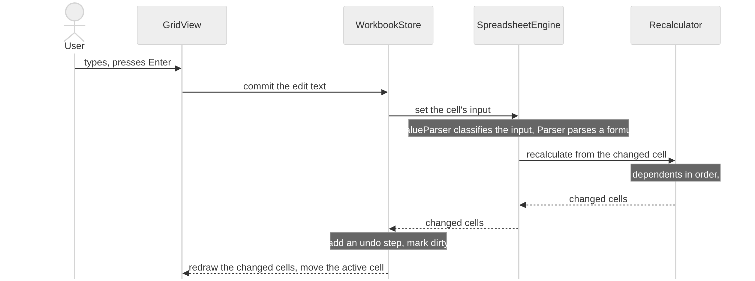

4.2 Save a workbook
Auto-save runs the same steps from “workbook to JSON” on, without the dialog and with M-16 instead of M-04. The recovery copy is written the same way to its own path. A crash or a full disk during the write must leave either the old or the new file (one way to do this is in 6.3).
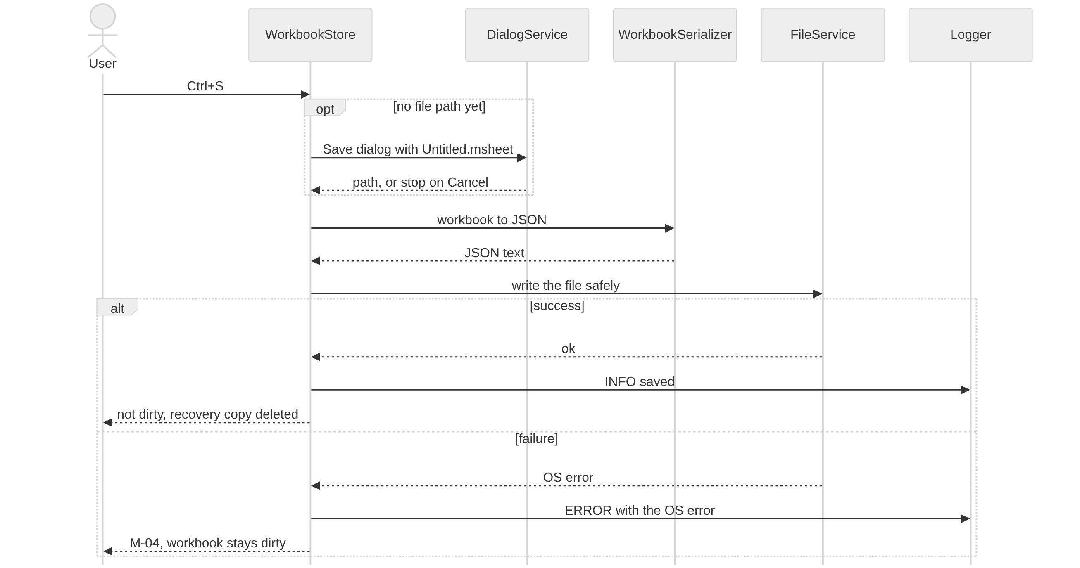

4.3 Import a CSV file
Cancel in the Open dialog or in W2 ends the import without changes.
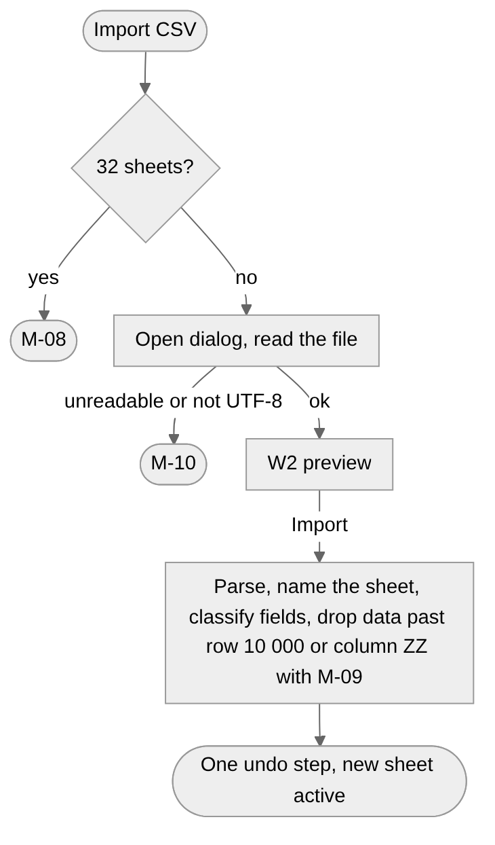

4.4 Start-up and recovery
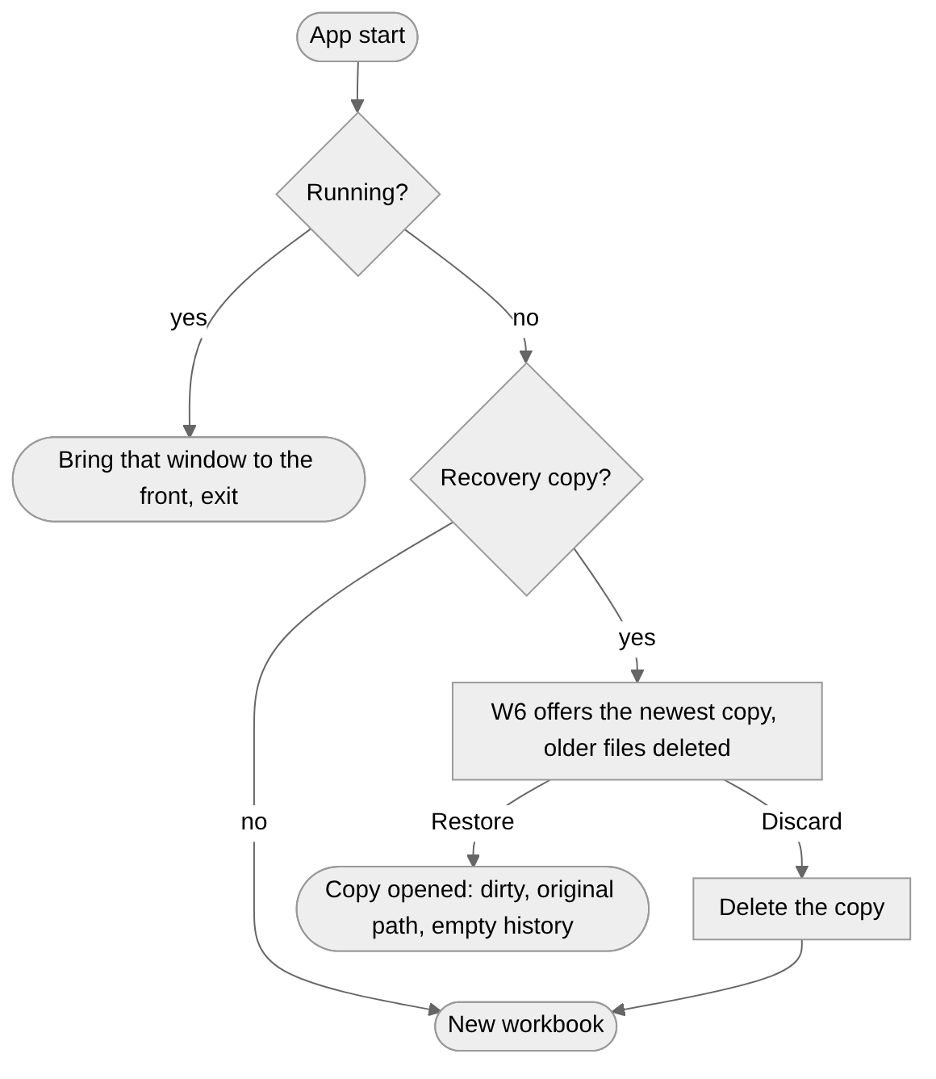
After start-up, the recovery timer runs every 120 s (3.11.1).

5. Non-functional requirements
Targets are measured on a PC with a 4-core CPU, 8 GB RAM and an SSD, running Windows 11 x64, with a release build and a workbook of up to 100 000 non-empty cells.

5.1 Limits
Item | Limit
Rows, columns per sheet | 10 000 rows (1 to 10 000), 702 columns (A to ZZ)
Sheets per workbook | 1 to 32
Sheet name | 1 to 31 characters
Cell raw input | 32 767 characters
Formula | 8 192 characters, 64 nesting levels, 255 function arguments
Column width | 20 to 1 000 px, default 100 px
Row height | 16 to 400 px, default 24 px
Decimals | Number 0 to 10, Currency 0 to 4, default 2
Decimal precision | 28 significant digits
Date range | 0001-01-01 to 9999-12-31
Undo history | 100 steps
Recovery copy interval | 120 s
Window size | Minimum 800 x 600 px, default 1 280 x 800 px

5.2 Requirements
ID | Category | Requirement | Verification
NFR-01 | Performance | A cold start shows an empty workbook in under 2 s | Stopwatch from launch to an editable grid
NFR-02 | Performance | Committing a cell with up to 1 000 dependents recalculates and repaints in under 100 ms | Automated benchmark
NFR-03 | Performance | Scrolling stays at 50 fps or more, with only visible rows and columns rendered | Performance monitor
NFR-04 | Performance | Opening or saving a 100 000-cell workbook takes under 3 s | Generated test file
NFR-05 | Capacity | Every limit in 5.1 works | Unit tests at each limit
NFR-06 | Reliability | Saving is atomic: a failed save never damages the previous file | Kill the process during a save
NFR-07 | Reliability | After a crash at most 120 s of changes are lost | Edit, wait 150 s, kill the process, restart: W6 offers the edit
NFR-08 | Correctness | Currency cells holding 0.1 and 0.2 sum to exactly 0.3 | Unit test
NFR-09 | Platform | Runs on Windows 10 version 1809 or later and Windows 11, x64 | Install test
NFR-10 | Usability | Every Must feature works with the mouse and with the keyboard alone | Manual test
NFR-11 | Security | No network access and no telemetry | Firewall log
NFR-12 | Maintainability | core has no React imports, and core, io and state have at least 80 % unit-test coverage | ESLint rule, coverage report
NFR-13 | Supportability | Every failure listed under ERROR in 3.11.3 leaves a log entry with the OS error or stack trace | Save to a read-only file, then read the log

6. High-level architecture
This section is the blueprint of the components and how they depend on each other. Class names are the ones used in sections 3 and 4. Their methods and internal data are left to the implementing team.

6.1 Package diagram
Arrows point to the package that is imported.
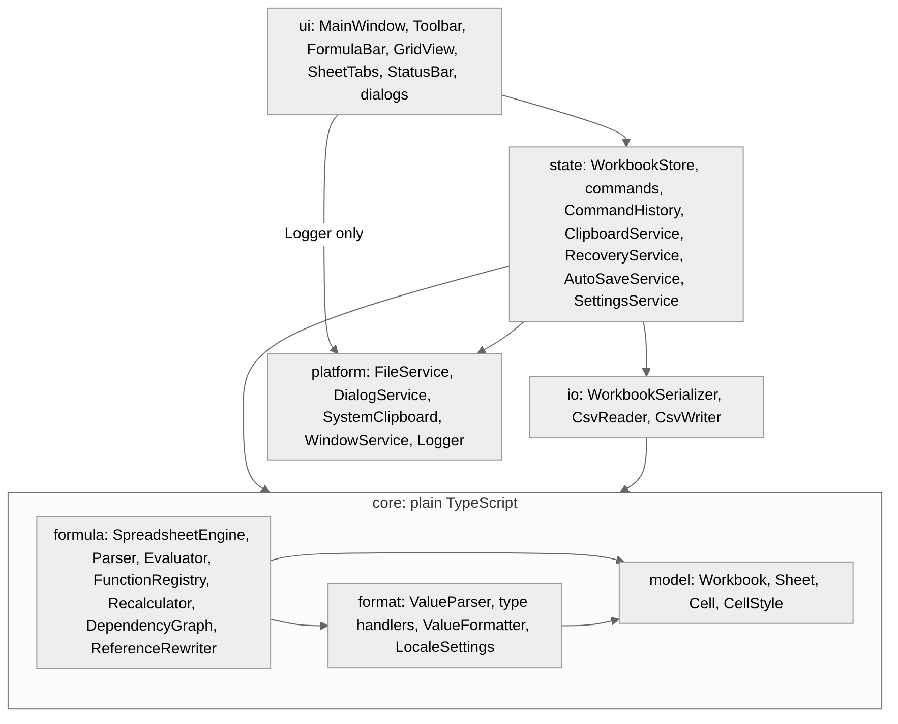
Package | Responsibility
core | All spreadsheet logic: model, input classification, display text, formulas, recalculation. Plain TypeScript without I/O or logging, unit-tested without starting the app
io | Converts the workbook to and from .msheet JSON and CSV text and validates files (8.3). Never touches the disk
platform | The only package that calls native modules: files, Windows dialogs, clipboard, window, single-instance check, log file
state | Holds the open workbook, runs every undoable step, runs the recovery and auto-save timers, loads and saves settings, and turns failures into messages and log entries
ui | The only package that imports React Native. Reads state and asks it for changes, never changes the model itself. The app entry installs the global handler that logs unhandled exceptions (3.11.3)
Errors are handled differently in each package. core never throws for user mistakes, which become error values (3.5.5). io returns a success or failure result with a reason. platform fails with the OS error code and message. state shows the matching message (7.2) and writes the log entry.
Item | Technology | Status
Language and UI | TypeScript (strict) with React Native for Windows | Required
State store | Zustand | Recommended
Native access | react-native-fs, @react-native-clipboard/clipboard, and a team-written native module for dialogs, the window and the single-instance check | Recommended
Tests | Jest | Recommended

6.2 Class diagram

Core components
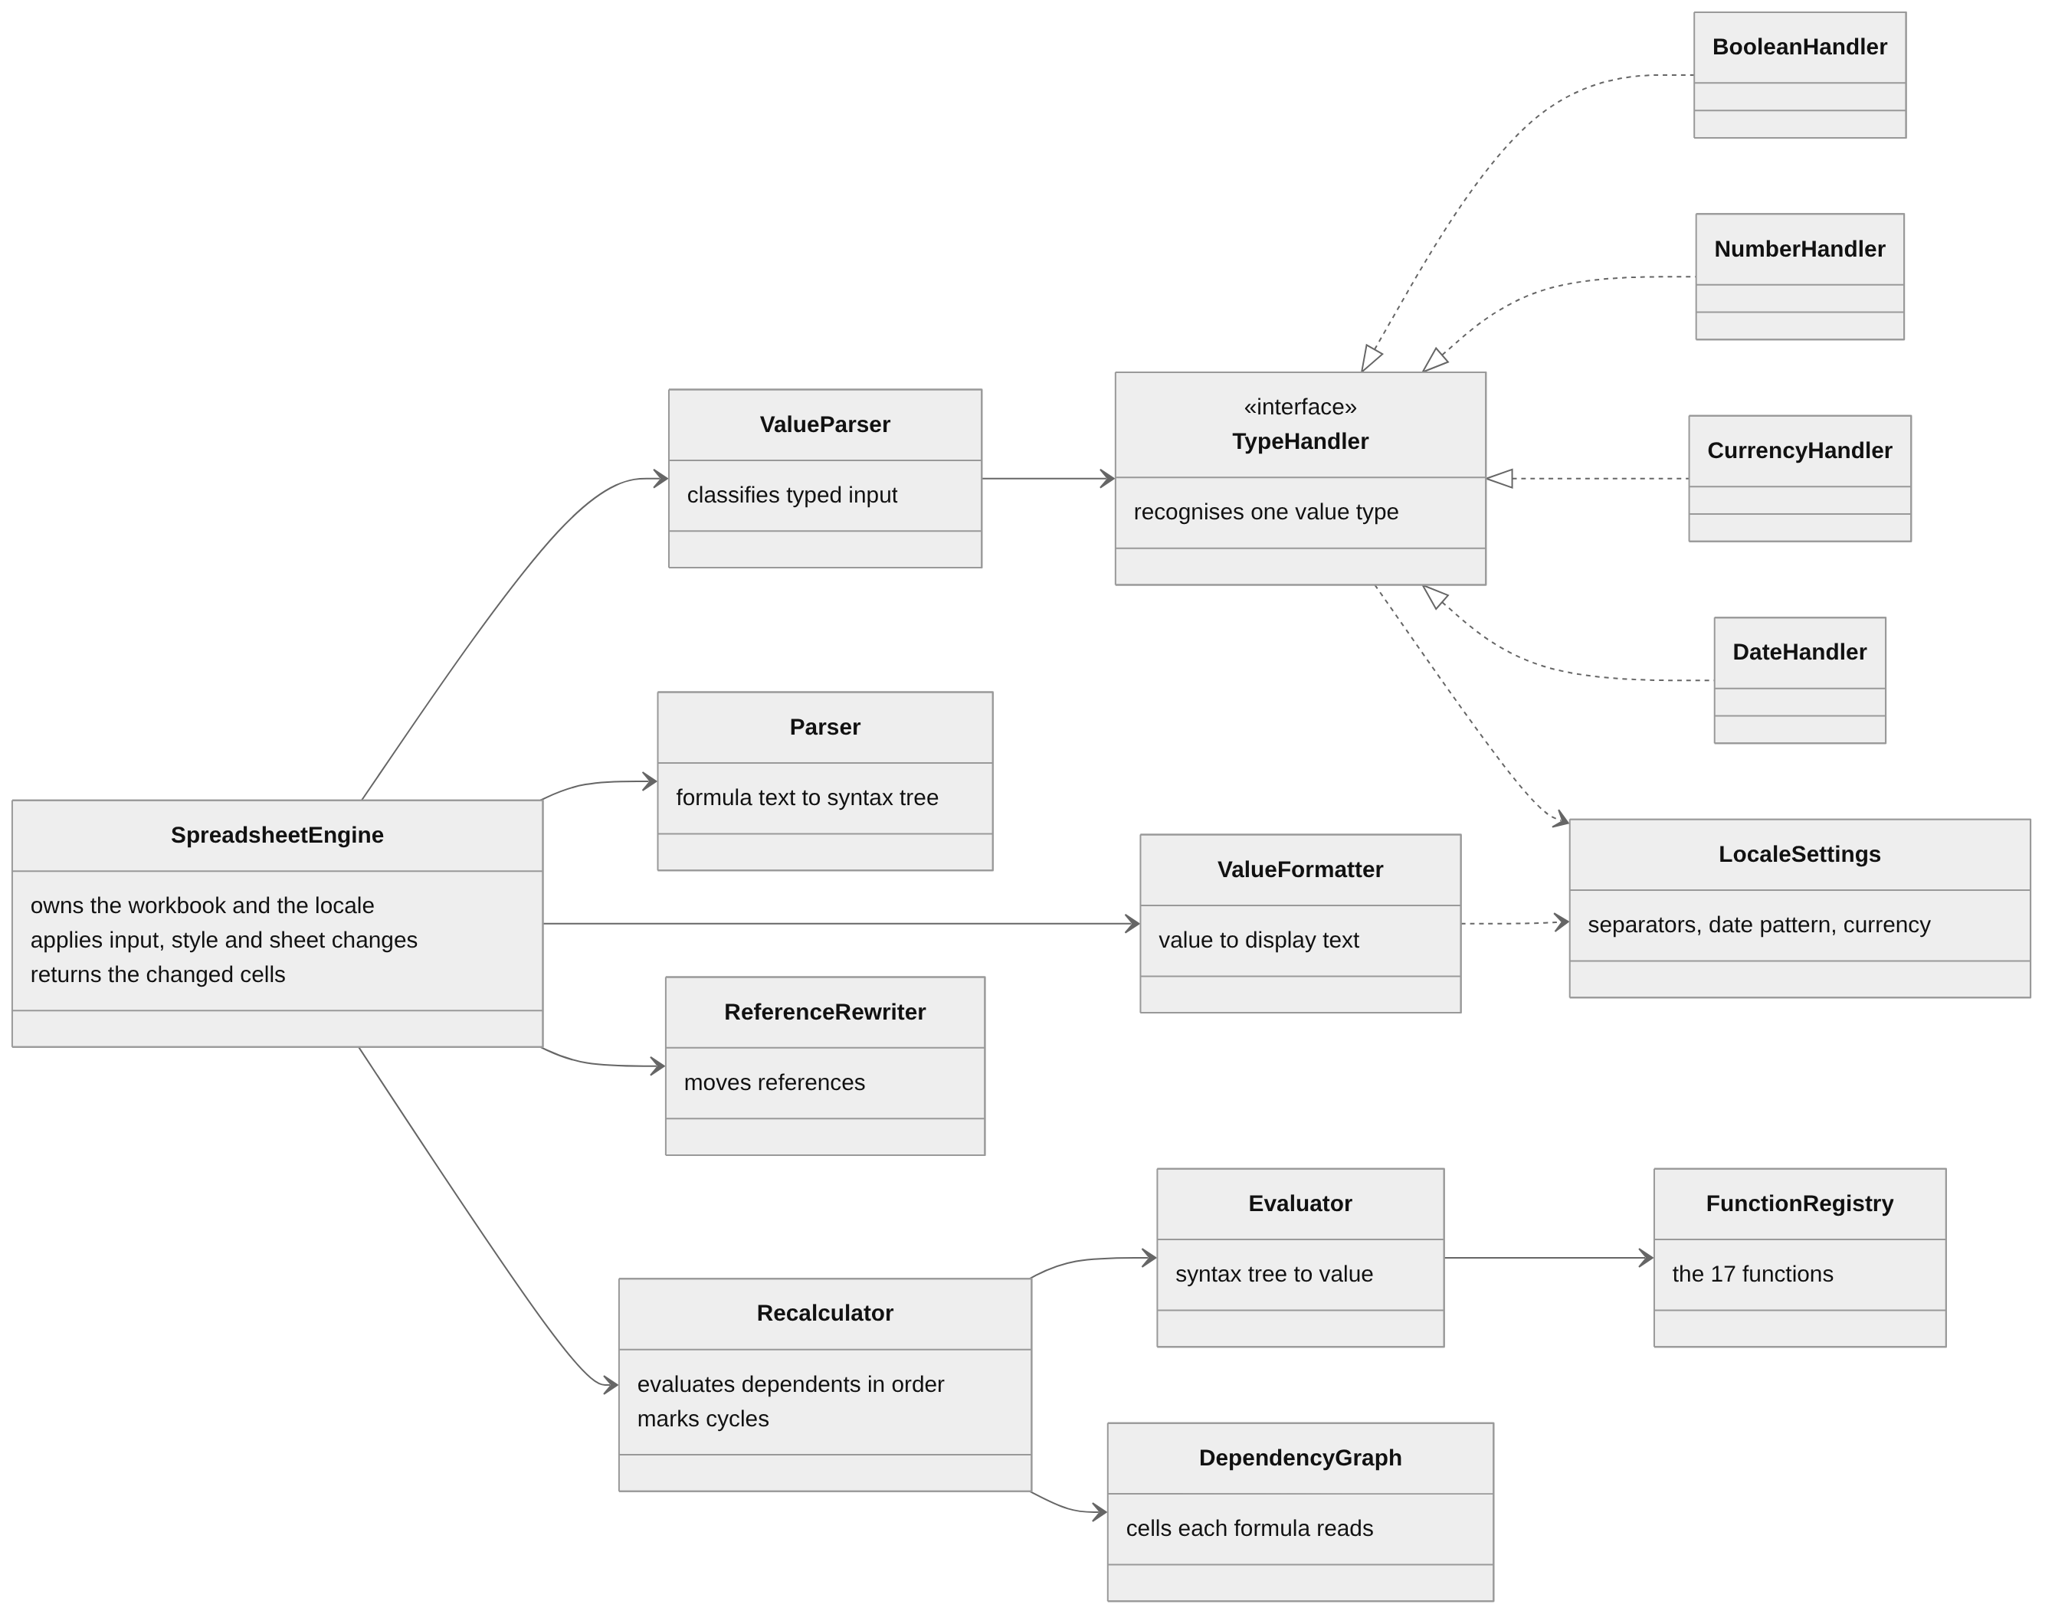

Application components (state, io, platform)
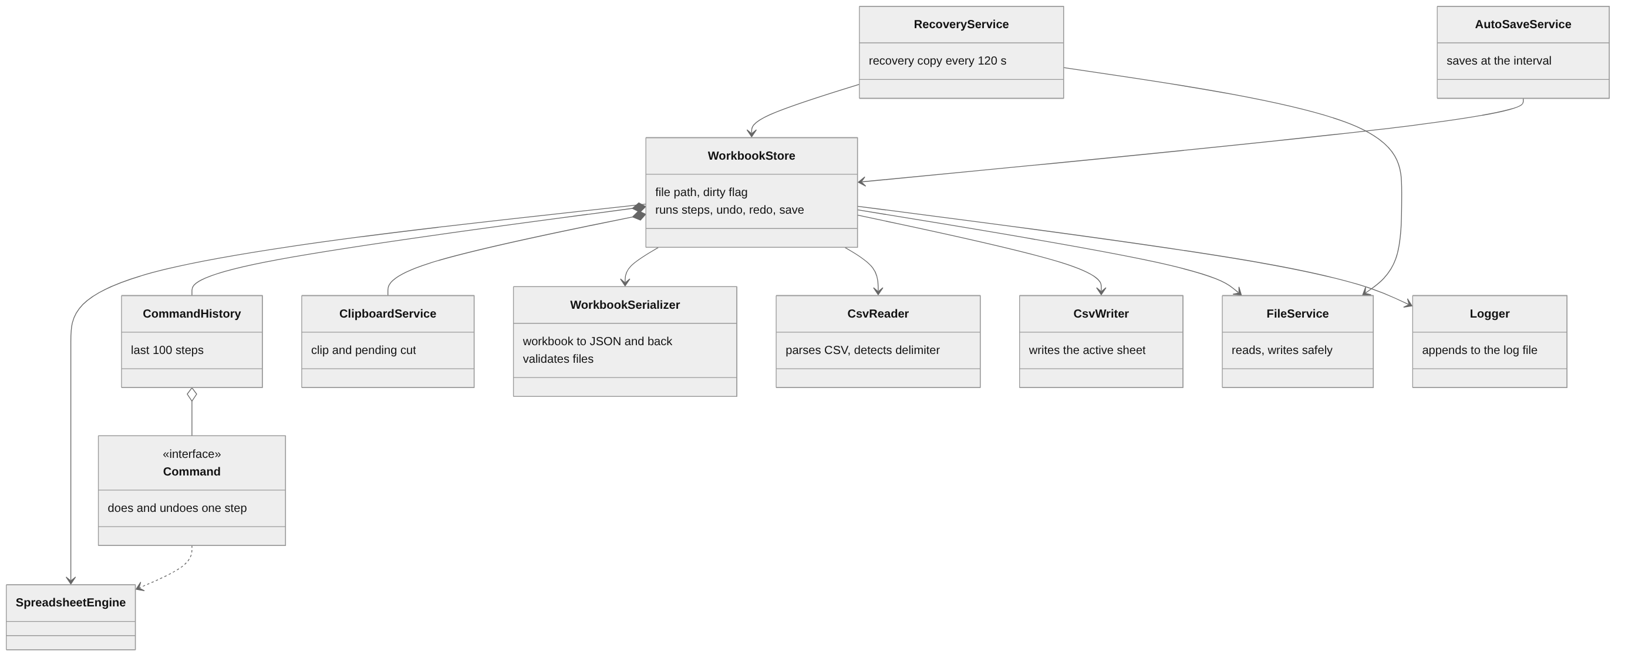
WorkbookStore runs every undoable step as a Command that calls SpreadsheetEngine. Nothing else changes the Workbook, so raw input, formulas and values stay consistent. Running a step commits an edit in progress, cancels a pending cut, executes the command, adds it to CommandHistory, marks the workbook dirty and redraws the changed cells. Each command stores what its undo needs: the previous raw input and style of the cells it changes, a removed sheet with its position, or the id of an added sheet.

6.3 Implementation recommendations
These are our suggestions, not requirements. Any other approach that gives the behaviour of section 3 and meets the targets of section 5 is acceptable.
Area | Recommendation | Related
Formula parsing | A recursive-descent Parser that follows the precedence in 3.5.2 and builds a syntax tree. The tree is kept per cell, so a formula is not parsed again on every recalculation | 3.5.1
Recalculation | Recalculator keeps a DependencyGraph per sheet (formula cell to the cells it reads) and orders the affected cells with Kahn’s algorithm. Cells left when the queue empties are on or behind a cycle. A range registers each of its cells, except a range of more than 10 000 cells, which is kept as one entry and matched by containment | 3.5.6, NFR-02
Exact decimals | decimal.js, rounding half away from zero | 3.5.4
Dates | A date-only type, such as Temporal.PlainDate with a polyfill or a small LocalDate class holding year, month and day. Not the JavaScript Date, which carries a time and a time zone and can shift a date by one day | 3.5.4
Display text | Intl.NumberFormat and Intl.DateTimeFormat inside ValueFormatter | 3.4.3
Undo and redo | The command pattern of 6.2, inside the Zustand store | 3.8
Safe file writes | Write <file>.tmp next to the target, then replace the target with it in one OS call | 3.9, 4.2, NFR-06

7. UI/UX wireframes

7.1 Screens
Dialogs are modal and centred on the main window. Enter activates the default button, Esc and the title-bar close button act as Cancel, and Tab moves between controls. Unavailable menu items and buttons are greyed out. Toolbar buttons show their name and shortcut as a tooltip. Open and save dialogs are the standard Windows dialogs.

W1 Main window
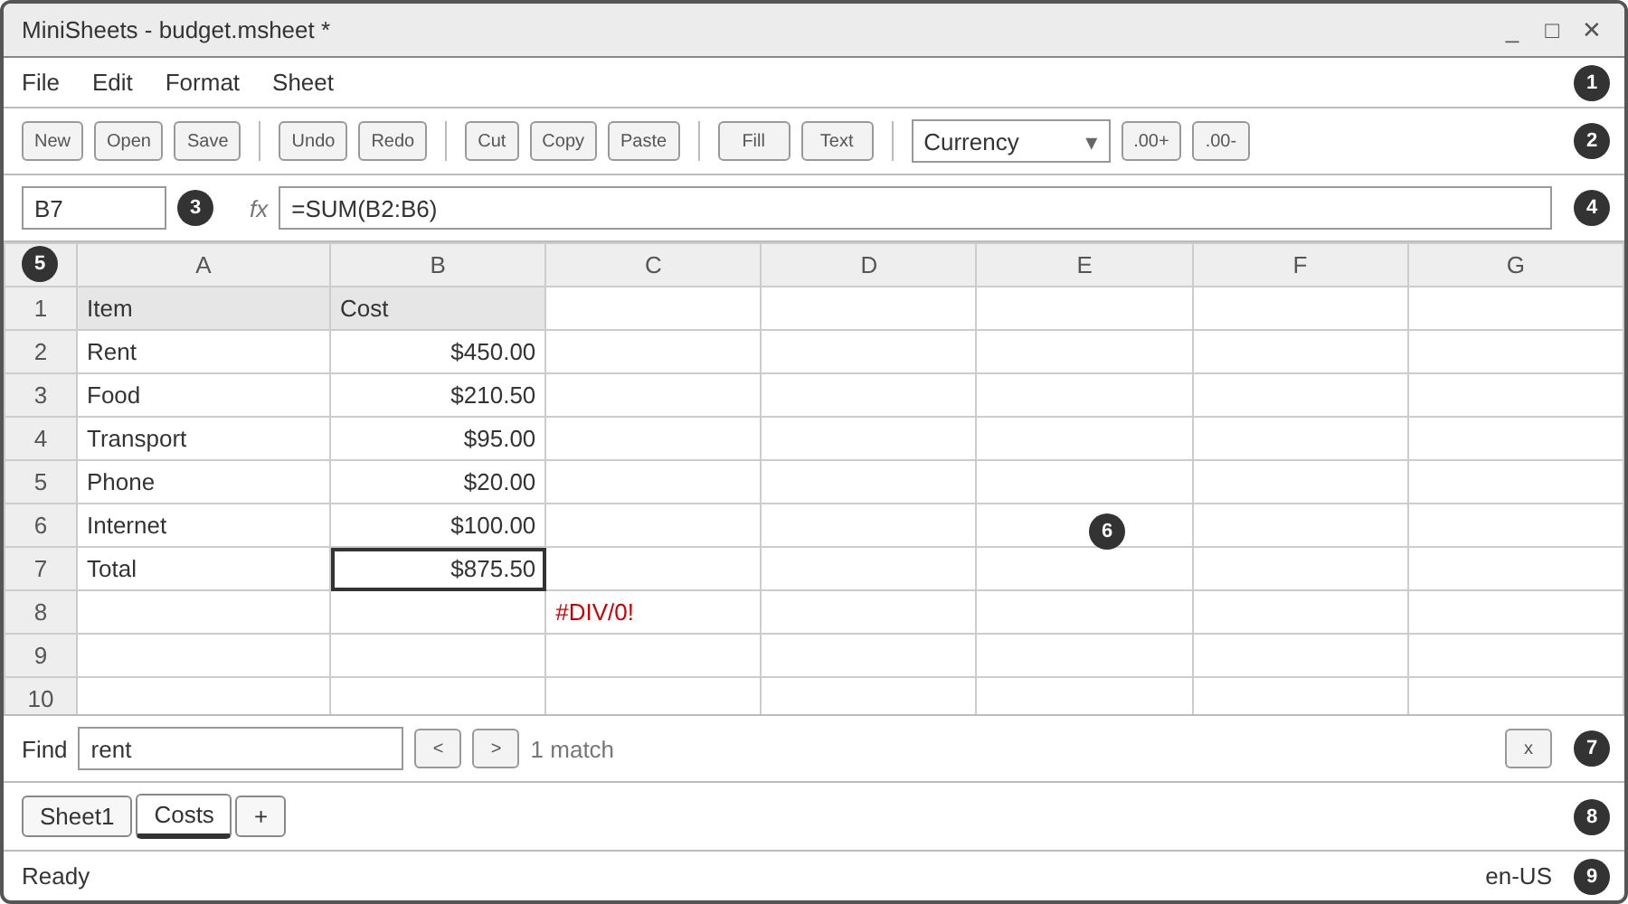
# | Element | Behaviour | Feature
1 | Menu bar | File, Edit, Format, Sheet (table below). Alt or F10 focuses it | F-12
2 | Toolbar | New, Open, Save; Undo, Redo; Cut, Copy, Paste; Fill, Text colour; format drop-down, .00+, .00- | F-12
3 | Name box | Address of the active cell (3.2.1) | F-01
4 | Formula bar | Edit text of the active cell; clicking it starts Edit mode | F-01, F-02
5 | Headers | Dragging a header border resizes the column or row | F-14
6 | Grid | Click selects a cell, typing starts Enter mode and double-click Edit mode. Only visible rows and columns are rendered | F-01
7 | Find bar | Hidden until Ctrl+F | F-16
8 | Sheet tabs | Click switches, double-click renames, + adds a sheet | F-09
9 | Status bar | Left: the mode (Ready, Enter, Edit), replaced for 5 s by a status message (a newer message replaces an older one). Right: the locale | F-01, F-10

Menu | Items (shortcut) | Feature
File | New (Ctrl+N), Open (Ctrl+O), Save (Ctrl+S), Save as (Ctrl+Shift+S), Import CSV, Export CSV, Settings, Exit | F-07, F-08, F-10
Edit | Undo (Ctrl+Z), Redo (Ctrl+Y), Cut (Ctrl+X), Copy (Ctrl+C), Paste (Ctrl+V), Clear contents (Delete), Find (Ctrl+F) | F-01, F-05, F-06, F-16
Format | Number format (General, Text, Number, Currency with Locale default, EUR, USD, GBP, Date), Increase decimals, Decrease decimals, Fill colour, Text colour, Borders | F-03, F-04, F-17
Sheet | Add sheet (Ctrl+Shift+N), Rename sheet, Delete sheet, Insert row above, Delete row, Insert column left, Delete column | F-09, F-18

W2 Import CSV
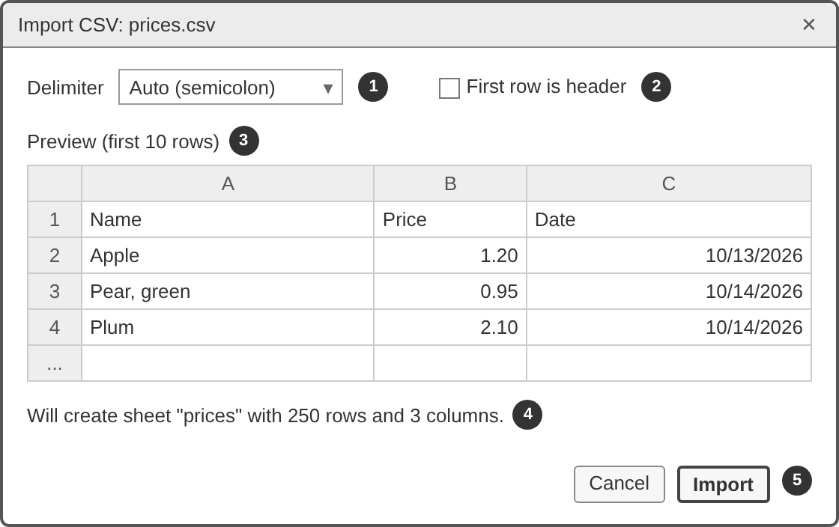
# | Control | Behaviour | Feature
1 | Delimiter | Auto (shows the detected delimiter), Comma, Semicolon, Tab | F-08
2 | First row is header | Row 1 is imported as text | F-08
3 | Preview | The first 10 rows as they will appear after import | F-08
4 | Summary | Will create sheet "<name>" with <rows> rows and <columns> columns. | F-08
5 | Import, Cancel | Import runs steps 5 to 9 of 3.10.1, Cancel closes | F-08

W3 Export CSV
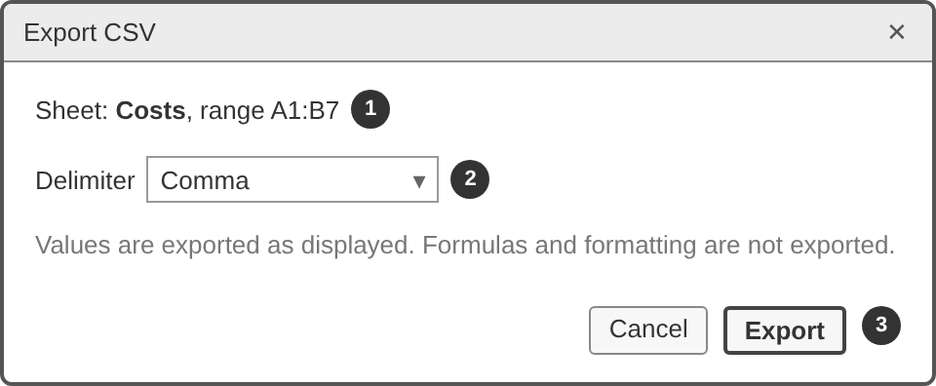
# | Control | Behaviour | Feature
1 | Sheet and range | The active sheet and the range that will be written | F-08
2 | Delimiter | Comma, Semicolon or Tab, default by locale (3.10.2) | F-08
3 | Export, Cancel | Export opens the Windows Save dialog, Cancel closes | F-08

W4 Settings
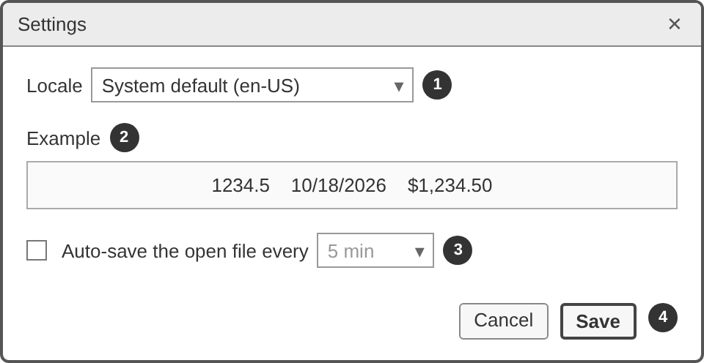
# | Control | Behaviour | Feature
1 | Locale | System default (with the resolved locale in brackets), en-US, lt-LT | F-10
2 | Example | 1234.5, the date 2026-10-18 and 1234.50 in the locale’s currency, in the chosen locale | F-10
3 | Auto-save | Checkbox (off by default) and interval. The interval is disabled while the box is unticked | F-15
4 | Save, Cancel | Save stores and applies the settings, Cancel closes | F-10, F-15

W5 Message box
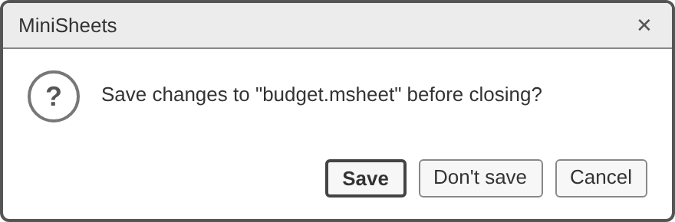
One dialog for every confirmation, warning and error. Title, text and buttons come from the message catalogue (7.2). The picture shows M-01, the unsaved-changes check. Error messages have a red icon and an OK button, warnings an amber icon, confirmations a question icon.

W6 Recover workbook
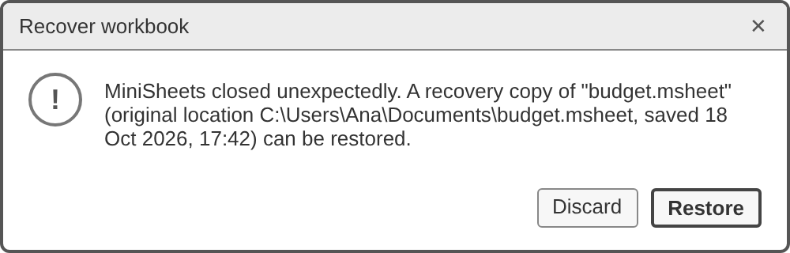
Shown at start-up before the main window accepts input (3.11.1) with text M-03. Restore is the default button. Esc and the close button also act as Restore, so no work is lost by accident. Feature F-11.

7.2 Message catalogue
<OS message> is the text Windows returns for the failed file operation.
ID | Shown in | Title | Text | Buttons
M-01 | W5, confirm | MiniSheets | Save changes to “<file name>” before closing? | Save (default), Don’t save, Cancel
M-02 | W5, warning | Delete sheet | Delete sheet ‘<name>’? You can undo this with Ctrl+Z. | Delete (default), Cancel
M-03 | W6 | Recover workbook | MiniSheets closed unexpectedly. A recovery copy of “<file name>” (original location <path> or “not saved yet”, saved <d MMM yyyy, HH:mm>) can be restored. | Restore (default), Discard
M-04 | W5, error | Save failed | Could not save “<file name>”. <OS message> The file on disk was not changed. | OK
M-05 | W5, error | Cannot open file | “<file name>” is not a valid MiniSheets workbook. | OK
M-06 | W5, error | Cannot open file | “<file name>” was saved by a newer version of MiniSheets. | OK
M-07 | W5, error | Cannot open file | Could not read “<file name>”. <OS message> | OK
M-08 | W5, warning | Sheet limit | A workbook can have at most 32 sheets. | OK
M-09 | W5, warning | Import CSV | Only the first 10 000 rows and 702 columns of “<file name>” were imported. | OK
M-10 | W5, error | Import CSV | Could not read “<file name>” as UTF-8 text. <OS message> | OK
M-11 | W5, error | Export CSV | Could not export to “<file name>”. <OS message> | OK
M-12 | W5, warning | Insert row | Cannot insert a row: row 10 000 is not empty. | OK
M-13 | W5, warning | Insert column | Cannot insert a column: column ZZ is not empty. | OK
M-14 | Tooltip on the tab |  | A sheet name needs 1 to 31 characters, none of ! : / ? * [ ], and must differ from the other sheet names.
M-15 | Tooltip on the triangle |  | This value is not a valid <format> value and is stored as text.
M-16 | Status bar |  | Auto-save failed: <OS message>
M-17 | Status bar |  | Could not write the recovery copy: <OS message>
M-18 | Status bar |  | Exported “<sheet name>” to <file name>.
M-19 | Find bar |  | No matches

7.3 Keyboard shortcuts
Shortcuts of menu items are listed in the menu table of W1. Other keys:
Key | Action
Arrow keys | Ready: move the active cell. Enter mode: commit and move
Enter, Shift+Enter | Commit and move down or up. In the find bar: next or previous match
Tab, Shift+Tab | Commit and move right or left
Esc | Cancel editing, cancel a pending cut, close the find bar, a menu or a dialog
F2, double-click | Edit mode
Delete, Backspace | Ready: clear the active cell
Home, Ctrl+Home | Column A of the current row, or A1
Page Up, Page Down | One screen up or down
Alt, F10 | Focus the menu bar
Ctrl+Page Down, Ctrl+Page Up | Next or previous sheet

7.4 Screen transitions
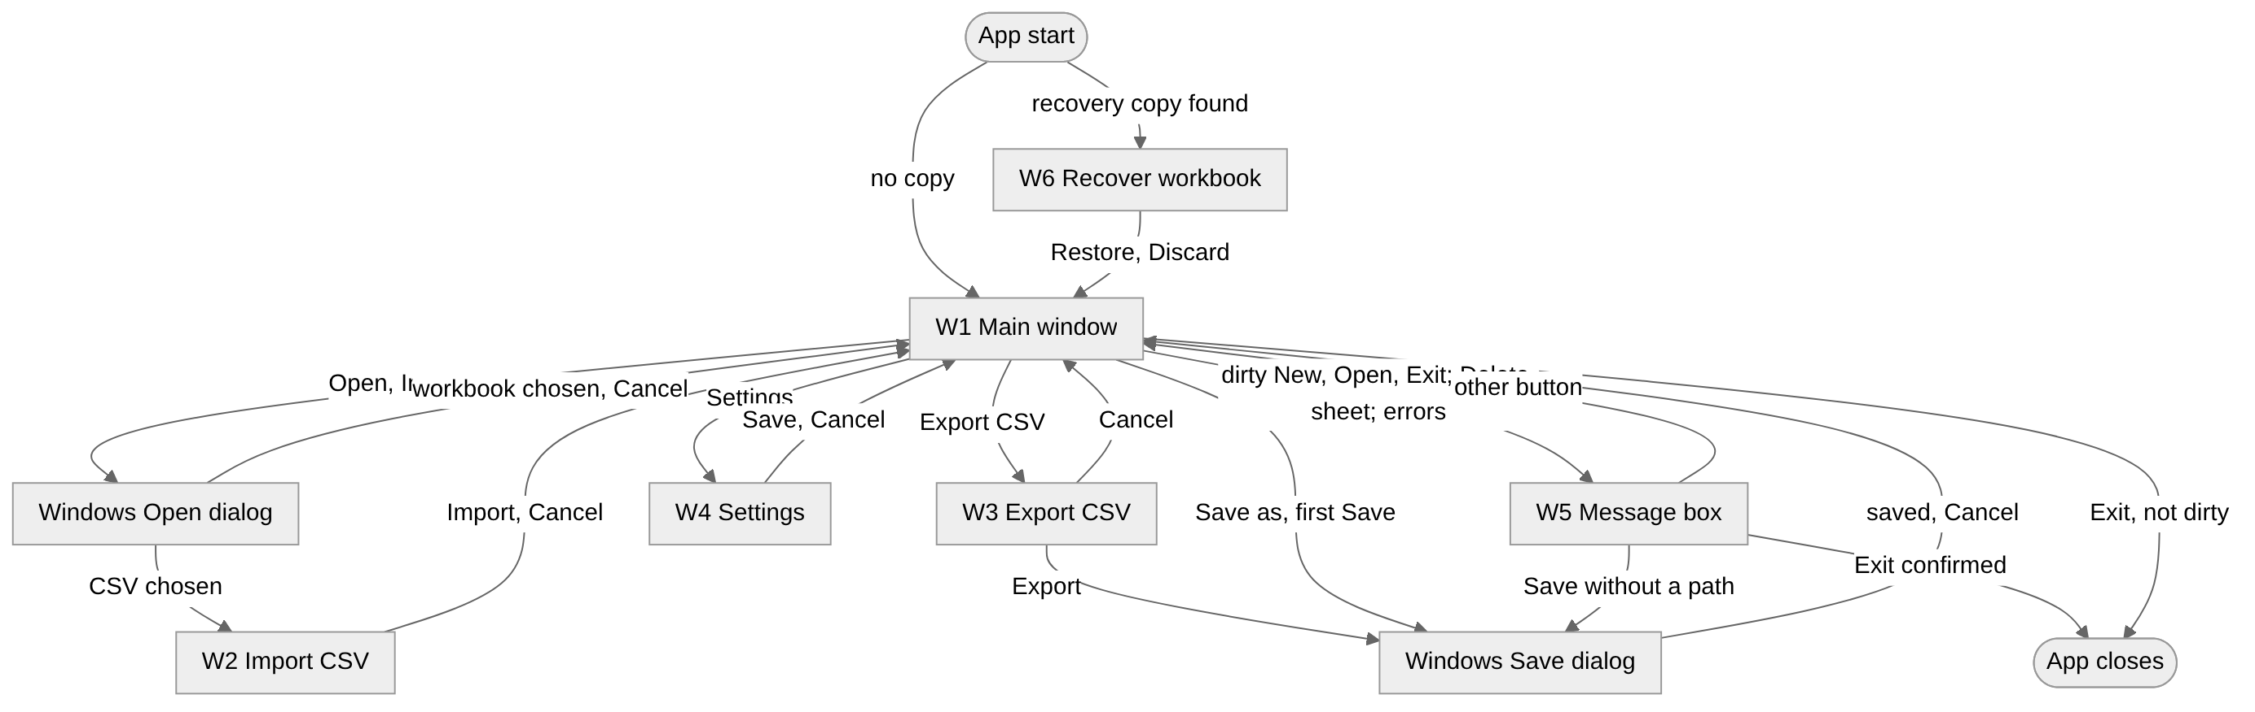

8. Data model
Cells are stored sparsely: only cells with content or a non-default style exist. Identical styles share one entry in a style table. Persistent entities are saved in the .msheet file, and runtime types exist only in memory.

8.1 Class diagram
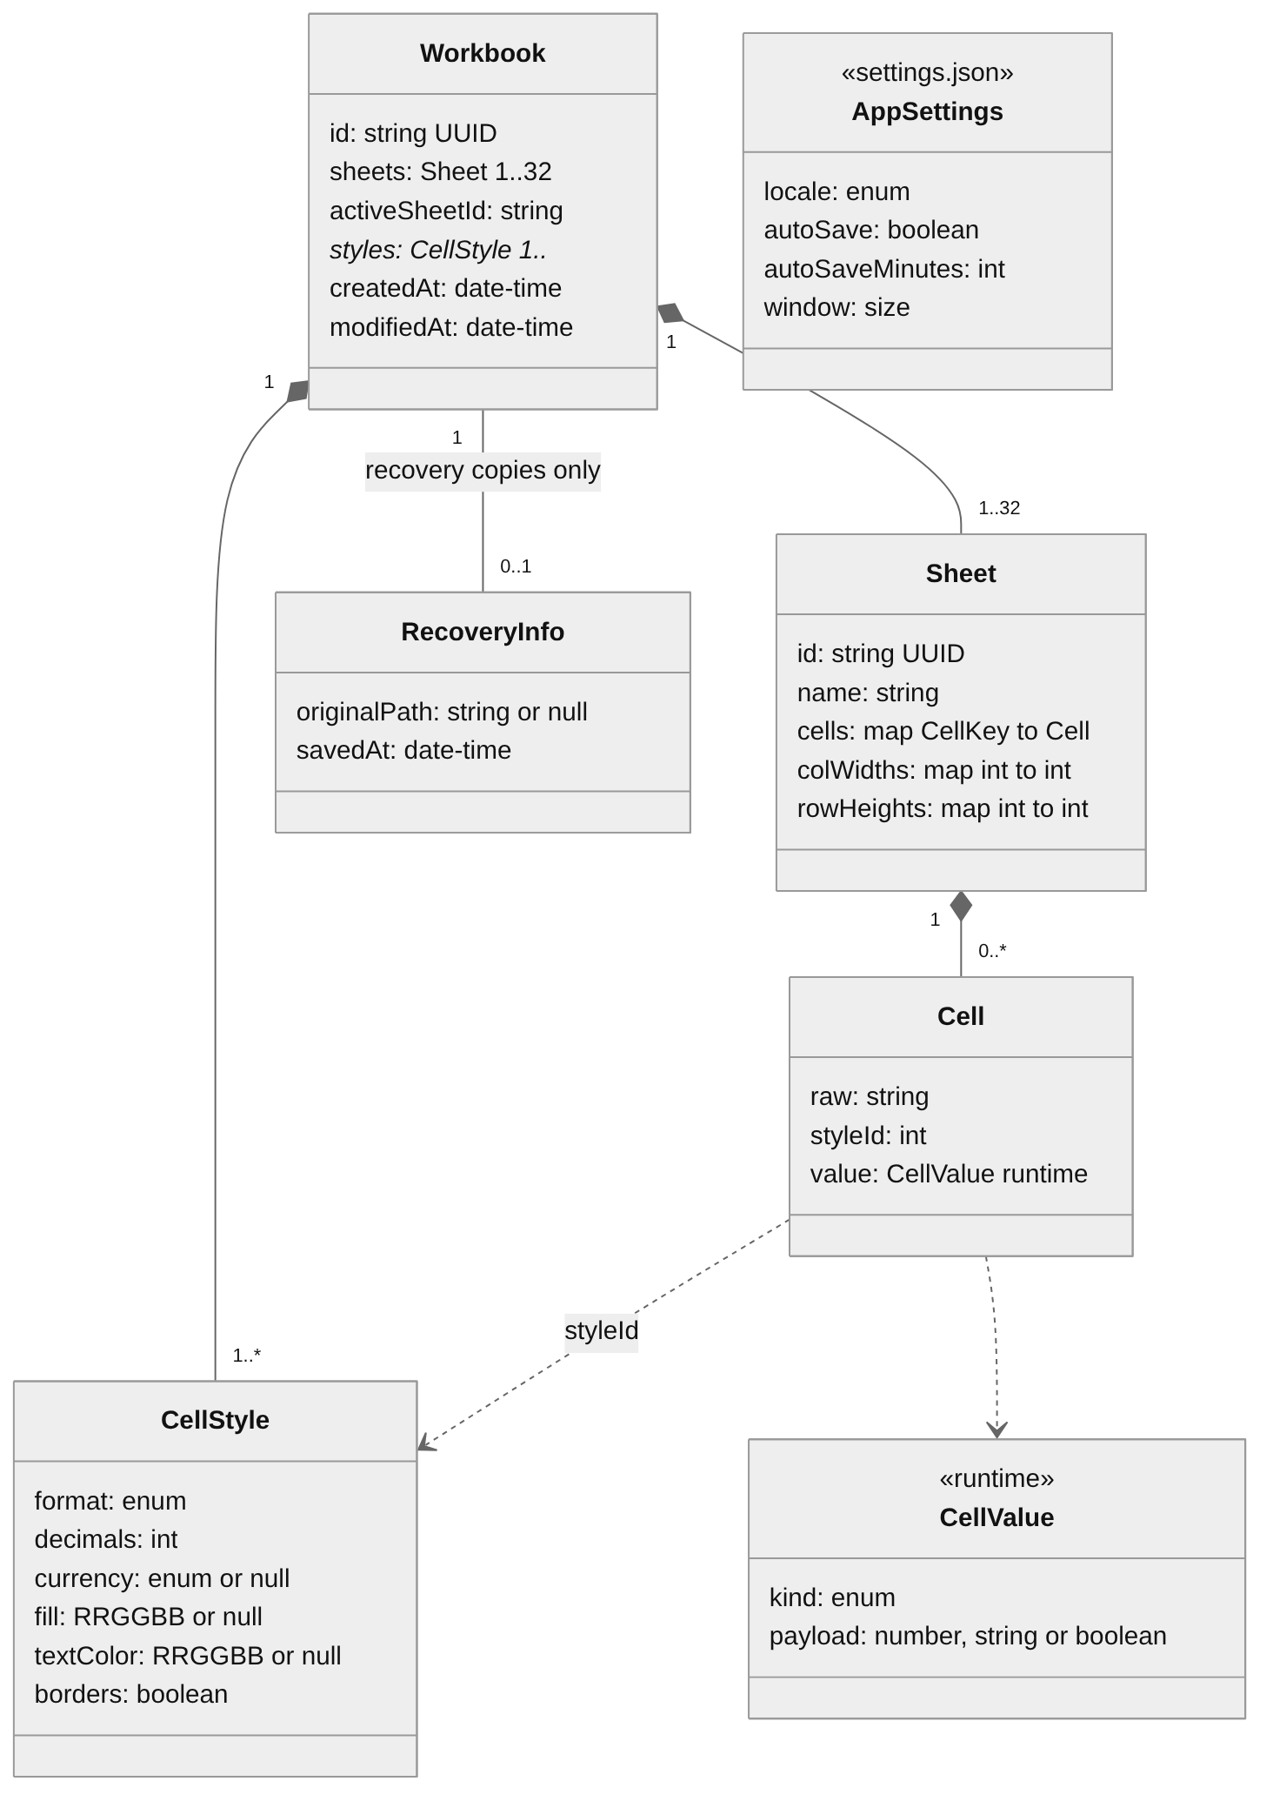

8.2 Entities

8.2.1 Workbook
Field | Type | Notes
id | string (UUID v4) | Created by New and kept by Save as. Names the recovery copy
sheets | Sheet[] | 1 to 32, in tab order
activeSheetId | string | Restored on Open
styles | CellStyle[] | Style table. Index 0 is the default style
createdAt, modifiedAt | string (ISO 8601, UTC) | Set by New and by every save
The file path and the dirty flag belong to WorkbookStore, not to the workbook.

8.2.2 Sheet
Field | Type | Notes
id | string (UUID v4) | Unchanged by rename
name | string | Rules in 3.1
cells | Map<CellKey, Cell> | Key upper case without $, A1 to ZZ10000
colWidths, rowHeights | Map<int, int> | Index from 0 to size in px. A missing index means the default size

8.2.3 Cell
Field | Type | Notes
raw | string | Raw input in canonical form, "" for a styled empty cell
styleId | int | Index into Workbook.styles
value | CellValue | Runtime only
A cell with raw = "" and styleId = 0 is removed.

8.2.4 CellStyle
Field | Type | Default | Notes
format | General, Text, Number, Currency, Date | General | 3.4.1
decimals | int | 2 | Number 0 to 10, Currency 0 to 4
currency | EUR, USD, GBP or null | null | null means the locale’s default
fill, textColor | #RRGGBB or null | null | Palette colours only. null is white fill or black text
borders | boolean | false | F-17

8.2.5 CellValue
Kind | Payload | Example
empty | None
number | Finite IEEE-754 double | 1234.5
decimal | Exact decimal (3.5.4) | 1234.50
text | String | Rent
bool | TRUE or FALSE
date | ISO date | 2026-10-18
error | Error code of 3.5.5 | #DIV/0!
Values do not depend on the locale. Only ValueFormatter produces locale-specific text.

8.3 .msheet file format (version 1)
The file is the JSON form of Workbook, without computed values. Example:
{
"format": "minisheets",
"version": 1,
"id": "3f6c2a4e-8d1b-4f7a-9c2e-1b5d7e9f0a11",
"createdAt": "2026-10-18T17:00:00Z",
"modifiedAt": "2026-10-18T17:45:12Z",
"activeSheetId": "a1b2c3d4-0000-4000-8000-000000000001",
"styles": [ {}, { "fill": "#FFFF00" }, { "format": "Currency", "currency": "EUR" } ],
"sheets": [
{
"id": "a1b2c3d4-0000-4000-8000-000000000001",
"name": "Costs",
"colWidths": { "0": 140 },
"rowHeights": {},
"cells": {
"A1": { "raw": "Item", "style": 1 },
"B1": { "raw": "Cost", "style": 1 },
"A2": { "raw": "Rent" },
"B2": { "raw": "450", "style": 2 },
"B7": { "raw": "=SUM(B2:B6)", "style": 2 }
}
}
]
}
- UTF-8 without BOM, 2-space indent, LF line endings. Fields in the order of the example, sheets in tab order, cells by row and then column.
- Style fields equal to their default are omitted and unused styles are dropped. Index 0 is always {}. "style" is omitted when it is 0.
- A recovery copy adds "recovery": { "originalPath": <string or null>, "savedAt": <ISO date-time> } after "modifiedAt".
A file is validated when it is opened, and any failure rejects the whole file. A version above 1 gives M-06. Every other failure gives M-05:
- invalid JSON or format
- an invalid id or date-time
- not 1 to 32 sheets, duplicate sheet ids, a name that breaks the rules of 3.1, or an unknown activeSheetId
- a cell key outside A1:ZZ10000, a raw longer than 32 767 characters or containing a line break, or an unknown style index
- an invalid style value or a size outside the limits of 5.1
Unknown fields are ignored.

8.4 Settings file
%LOCALAPPDATA%\MiniSheets\settings.json, UTF-8 JSON. A missing or invalid file means all defaults (logged as WARN, 3.11.3). The same folder holds recovery\ (3.11.1) and logs\ (3.11.3).
Field | Type | Default
locale | "system", "en-US", "lt-LT" | "system"
autoSave | boolean | false
autoSaveMinutes | 1, 5, 10, 15 or 30 | 5
window | { width, height, maximized } | 1280, 800, false

